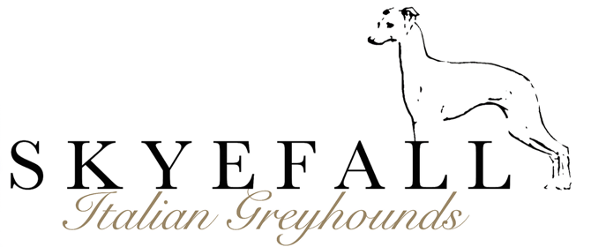

Puppy Questionnaire
Welcome to Skyefall Italian Greyhounds, our puppy questionnaire is designed to help allocate puppies with their future forever homes and to give myself a bit of an understanding into your day to day life. Completing this form does not guarantee you a puppy and it is important to know that if you are not contacted by me personally after sending in your questionnaire then you have not moved onto my waitlist at this time.

Care should be taken to thoroughly research the Italian Greyhound breed to ensure they are a suitable fit for your home and lifestyle. I implore you to be as honest as you possibly can during this process, this is not an interrogation, it is a tool to help me select the most suitable puppy in the litter for you so that you can start the rest of yours lives together on the right foot, or paw!

Questionnaires that are filled out thoughtfully and thoroughly will naturally take my preference when allocating my babies and only the most suitable of homes will be considered.

All puppies I breed are brought up in my home and are part of my family from the minute they enter this world and take their first breath right up to the moment they leave to live with their forever families. Italian Greyhounds are social dogs that require being part of their family’s everyday lives. They need human and canine interaction, mental and physical stimulation, environmental enrichment and a consistent approach to training to develop into well balanced and happy adults.

I only place my dogs in loving and safe environments, with families that have a thorough understanding of the needs of a puppy and Italian Greyhound. Puppies grow up to be adults and each stage produces its own challenges which you need to consider when purchasing a puppy. I strive hard to understand your needs and your circumstances and will endeavour to prepare you for years of devoted love and wonderful experiences an Italian Greyhound will bring to your life. As a devoted breeder I hope you understand that I only want the very best for my puppies and their families.

Skyefall puppies are raised following the ‘Puppy Culture’ protocols and you have access to my online puppy manual, shopping list and video tutorials.

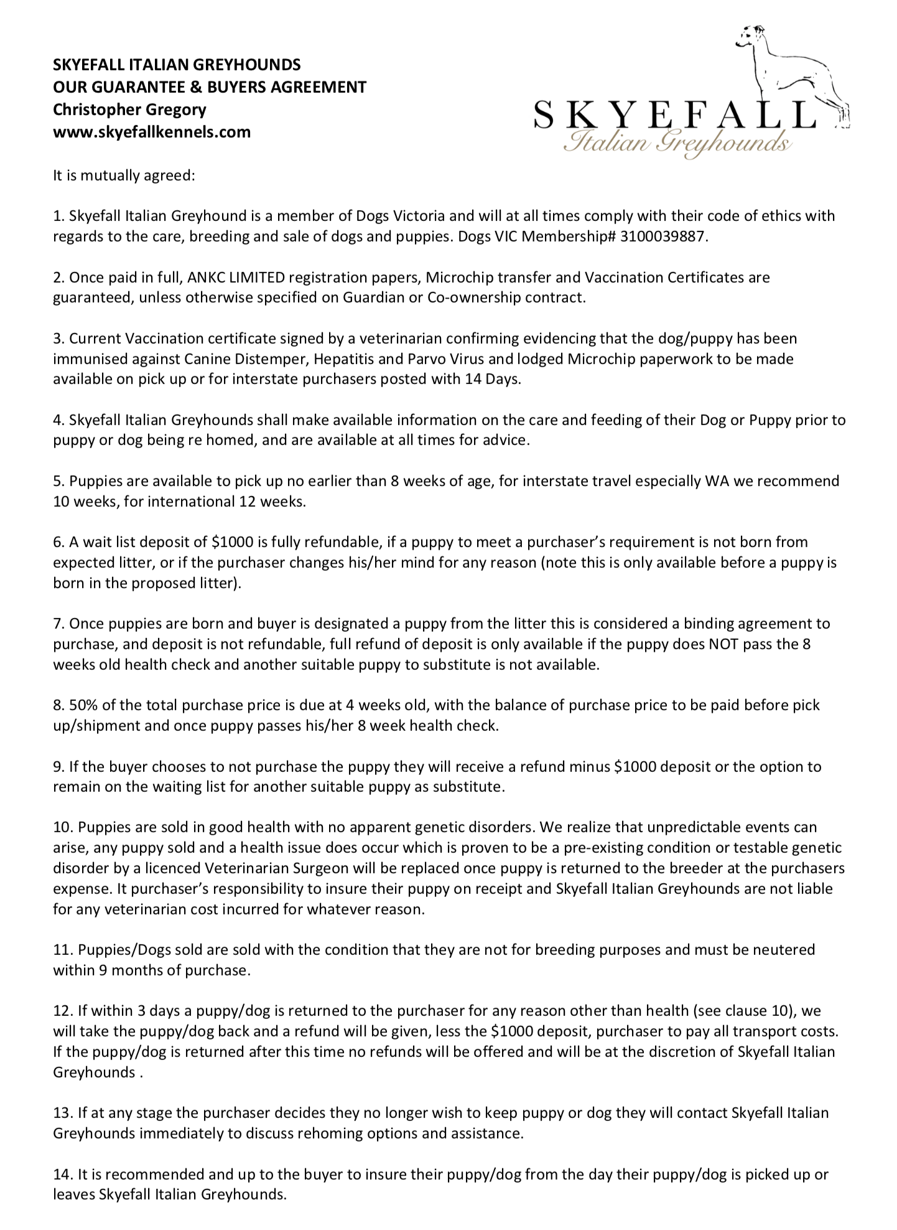
Your puppy will come with an extensive puppy pack to get you started and settled into life with their new family. Every mother is vet checked before breeding, during before whelping and again after whelping. Your puppy is vet checked at 3 days old, 8 weeks old and come with their first vaccination completed, microchipped, pedigree ANKC papers and lifetime breeder support!

I have read, understand and agree to the above buyers guarantee and agreement? Initial_________
Please complete the questionnaire below.
I will contact you after I receive and consider your form if you are successful. This may take weeks depending on the number of enquires I receive and how busy I am with my career and caring for my dogs etc.
PLEASE ANSWER EVERY QUESTION IN AS MUCH DETAIL AS YOU CAN.
Please delete the remaining lines after your answer.
Name: _______________________________________________________________
Address: ___________________________________________________________________

Phone Contact: ______________________________________________________
Email: _______________________________________________________________
Number of people living at your home: Adults: ___ Children: ___ Pets: ___
Ages of any children: _____________________

Question 1 - Do you want to buy a puppy/adolescent/mature dog?

Question 2 - Do you have a preference for a male or female puppy?
MALE / FEMALE / EITHER
Question 3 - Do you have a preference for colour?

Question 4 - Do you have dogs living at or visit your home? (breed and ages) ______________________________________________________________________
______________________________________________________________________

Question 5 - Do any have any other pets living in your home? (Type and ages)
______________________________________________________________________
______________________________________________________________________

Question 6 - Have you owned a dog in the past? How long ago? What breed?
______________________________________________________________________
______________________________________________________________________
______________________________________________________________________

Question 7- Have you ever owned an Italian Greyhound before? Y / N

Question 8 - What sort of dwelling do you live in and do you rent or own?
(e.g. house, flat, unit, rural property) Please attach photos in email.
______________________________________________________________________
______________________________________________________________________

Question 9 – What is the occupation of the adults in the family? On average, how many hours a day will your puppy be left on its own at home?
______________________________________________________________________
______________________________________________________________________

Question 10 - How do you intend to secure your puppy/adult dog when they are left at home? Will you continue with crate training your puppy?
______________________________________________________________________
______________________________________________________________________

Question 11 - Describe where your new puppy will live as a puppy and an adult (e.g. kennel outside, live in house, crate/playpen, garage etc.)?
______________________________________________________________________
______________________________________________________________________
______________________________________________________________________
______________________________________________________________________

Question 12 - Describe where your new dog will go to the toilet while left alone and in your company?
______________________________________________________________________
______________________________________________________________________
______________________________________________________________________

Question 13 - How do you plan to socialize and train your dog? Feel free to go into lots of detail!
______________________________________________________________________
______________________________________________________________________
______________________________________________________________________
______________________________________________________________________
______________________________________________________________________
______________________________________________________________________
______________________________________________________________________
______________________________________________________________________
______________________________________________________________________
______________________________________________________________________
______________________________________________________________________

Question 14 - Have you ever belonged to an obedience / dog club? Y / N

Question 15 - All pet puppies will come desexed, unless sold on a guardian contract to return to me for breeding. Do you understand this? Y / N
Please note this is not up for negotiation, I take the safety of my puppies incredibly seriously and I will not have them being used for breeding without my knowledge or guidance. If you are interested in breeding then please take note of question 22.

Question 16 - Will you take out pet insurance for your puppy? Y / N

Question 17 - Are you aware of the council requirements in your area regarding pet ownership? Y / N

Question 18 - Have you considered the costs involved in maintaining the health of your dog long term? (registration, vet checks, immunization, emergency surgery/care) Y / N

Question 19 - How did you hear about Skyefall Italian Greyhounds?
______________________________________________________________________
______________________________________________________________________

Question 20 - Do you intend to keep in contact with me throughout your puppies life? Y / N

Question 22- Are you interested in becoming a guardian home for one of our pick female or male puppies, this would mean your girl would come back for approx. 6 weeks to whelp and raise her litter for a maximum of 5 times should she be suitable for breeding after the age of 1 year old, then she would be desexed and live the rest of her life with her loving family. Please indicate your answer below, please note your answer WILL NOT affect whether you get a puppy REQUIRED (Please read this section of my website https://www.skyefallkennels.com/guardian)
- YES / NO / MORE INFORMATION

Lastly this space is provided for you to tell me anything further about yourself that will help me assess if a Skyefall Italian Greyhound would thrive in your home (e.g. your interests and hobbies, future plans i.e. starting a family, moving house, etc)
______________________________________________________________________
______________________________________________________________________
______________________________________________________________________
______________________________________________________________________
______________________________________________________________________
______________________________________________________________________
______________________________________________________________________
______________________________________________________________________
______________________________________________________________________
______________________________________________________________________
______________________________________________________________________
______________________________________________________________________

Thank you for taking the time to carefully complete this questionnaire.
If you have any other questions/queries, please do not hesitate to contact me!

P.S Please remember to attach supporting photos of your home, areas where the puppy will live, be contained when alone, toilet, any balcony if in an apartment, back yard etc.

Thank you,
Christopher Gregory
Skyefall Italian Greyhounds

